**PROJECT DOCUMENATION**

**PROJECT NAME : FISH FEEDER**

**Introduction:**

The Automatic Fish Feeder is a smart solution designed to automate the feeding process for aquarium fish using an ESP32 microcontroller and a servo motor. This project is particularly useful for fish owners who want to ensure their fish are fed on time, even when they are away.

The feeder is programmed to dispense a specific amount of fish food at scheduled intervals. The ESP32 acts as the central controller, executing the feeding mechanism by rotating the servo motor, which releases the food into the aquarium. The feeding time and quantity can be adjusted as per the requirements, ensuring proper nutrition for the fish.

This project also supports remote monitoring and control through MQTT (Message Queuing Telemetry Transport), making it possible to operate the feeder using a smartphone or web application. Additionally, sensors can be integrated to monitor parameters like water quality, temperature, or food levels for enhanced aquarium management.

**Components Used:**

1. **ESP32 Microcontroller**
   * Acts as the brain of the project, handling the communication, timing, and motor control.
   * Provides Wi-Fi and Bluetooth connectivity for remote control using MQTT.
2. **Servo Motor**
   * Responsible for the precise movement required to dispense fish food.
   * Controlled using PWM (Pulse Width Modulation) signals from the ESP32.
3. **Power Supply**
   * A 5V or 12V power adapter to provide sufficient power to the ESP32 and the servo motor.
4. **Fish Food Container**
   * A small compartment or container to store fish food, designed with an opening mechanism controlled by the servo motor.
5. **MQTT Broker**
   * Facilitates communication between the ESP32 and a mobile app or web application for remote monitoring and control.
6. **Wi-Fi Network**
   * Used for sending and receiving data via MQTT.
7. **Buzzer or LED Indicator** *(Optional)*
   * Provides alerts or notifications for successful feeding or errors.
8. **Cables and Connectors**
   * For powering and connecting all the components.

**Working Principle:**

1. **Scheduling**:
   * The ESP32 is programmed to follow a feeding schedule, using built-in timers or an RTC module.
2. **Food Dispensing**:
   * When the feeding time arrives, the ESP32 sends a PWM signal to the servo motor, rotating it to release a fixed amount of food from the container.
3. **Remote Control**:
   * Users can manually trigger the feeder or adjust feeding schedules using a mobile app connected via MQTT.
4. **Monitoring**:
   * Optional sensors can monitor the food level, aquarium temperature, or water quality, and send data to the user.

**Block Diagram:**

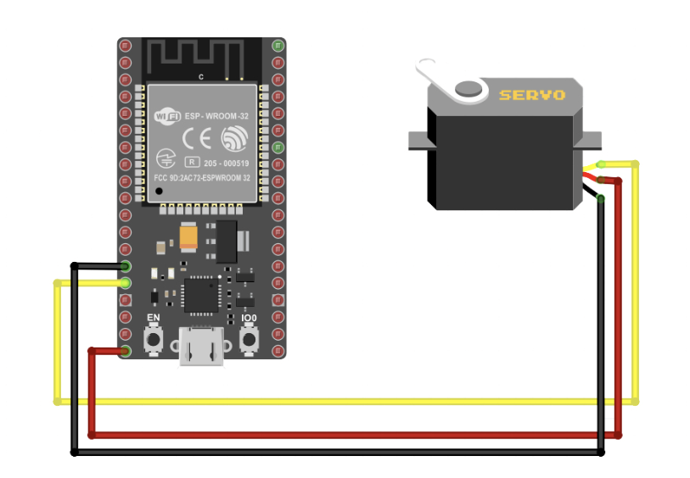

**Program:**

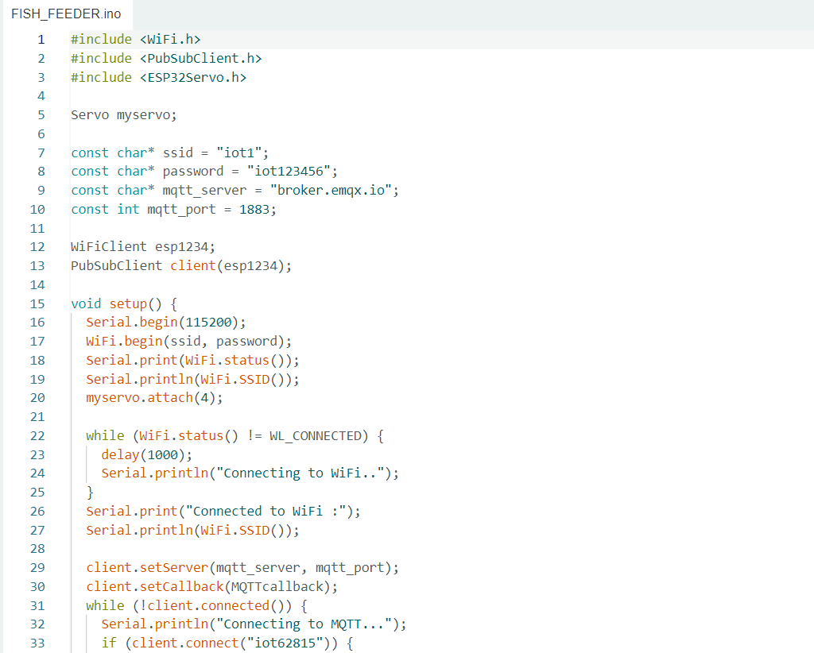

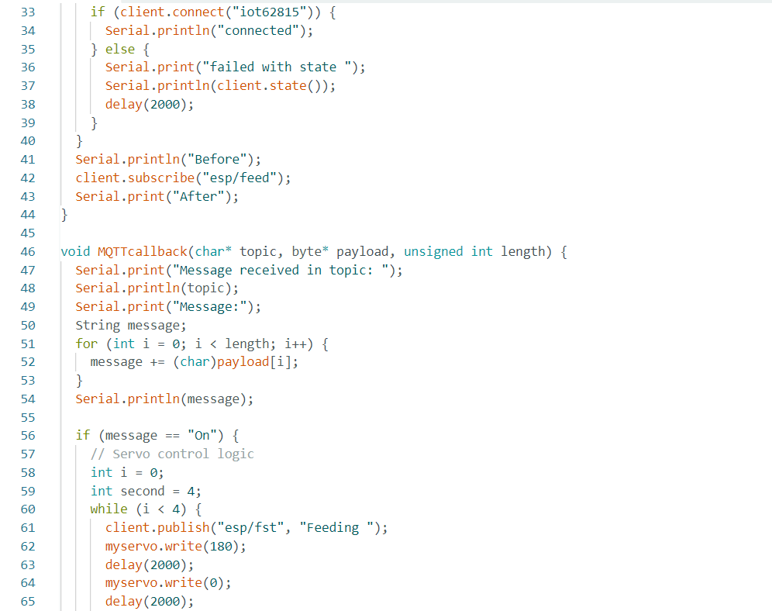

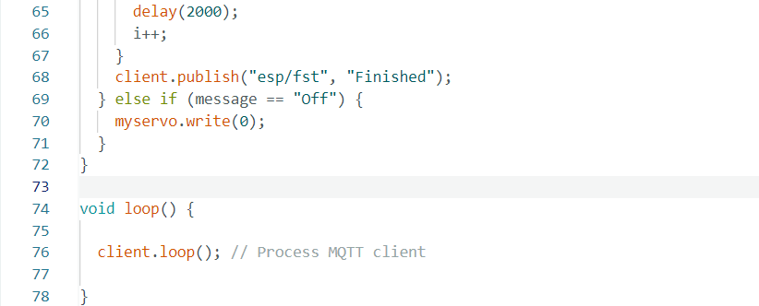

**Image:**

